
Year 10 -Pathway 2

Mini Test 5 -Semester 2

Statistics

Resources allowed: Calculator and 1 x A4 page one side

Name: ______________________ Class: ______ Time: 40 minutes Total Marks: ____/38

Show working and answers on this sheet. Show working in sufficient detail to support your answers. Incorrect answers without supporting reasoning may be allocated zero marks.

Question 1 (1,1,1,1 – 4 Marks)

- In a market survey, 200 people were asked how many hours of television they watched in the previous week. The results are presented in the boxplot below.
- 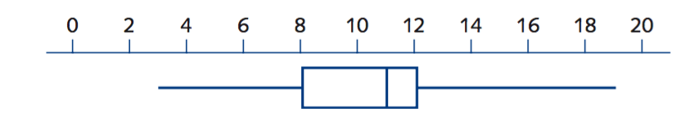
- What is the maximum number of hours anyone watched television?

- How many people watched more than 8 hours of television?

- What is the interquartile range?

- How many people watched between 8 hours and 11 hours of television?

Question 2 (1 marks)

The histogram and box plot below show how many hours that people spend watching televisions each week. Which data display can you use to find the largest number of hours?

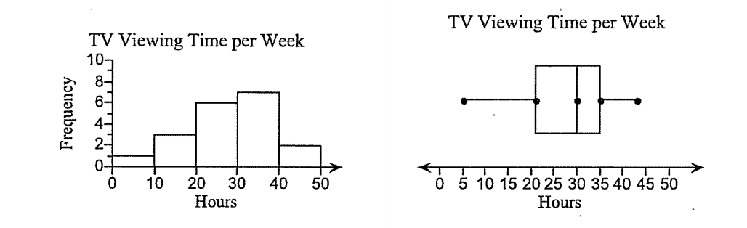
Select and circle the correct answer

- Box plot
- Box plot and histogram
- Histogram
- neither

Question 3 (3,2 – 5 Marks)
- The boxplot shows the distribution of test scores in a class (Class A) of 20 students.

- 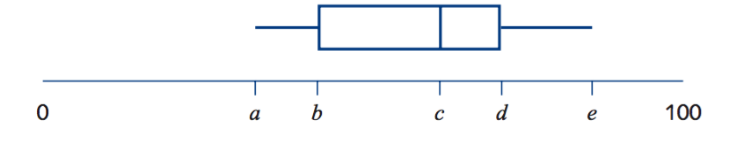
- The lowest score in the class was 38, the range of the scores was 50 and the median was 61.

- Write down the values of a = c = e =

- When all the test scores were added up the total was 1240. What was the mean of the test scores?

Question 4 (3,2,2 -7 Marks)
The number of late passes issued daily by a school over a four week period were as follows:

4, 4, 4, 5, 5, 6, 6, 6, 6, 7, 7, 7, 7, 8, 8, 8, 9, 9, 10, 14

- Determine the five number summary for this data.

- Is the value of 14 in the above list an outlier for the data set? Justify your answer.

- Use the five number summary to construct a box plot on the scale below that reflects your response in (b).

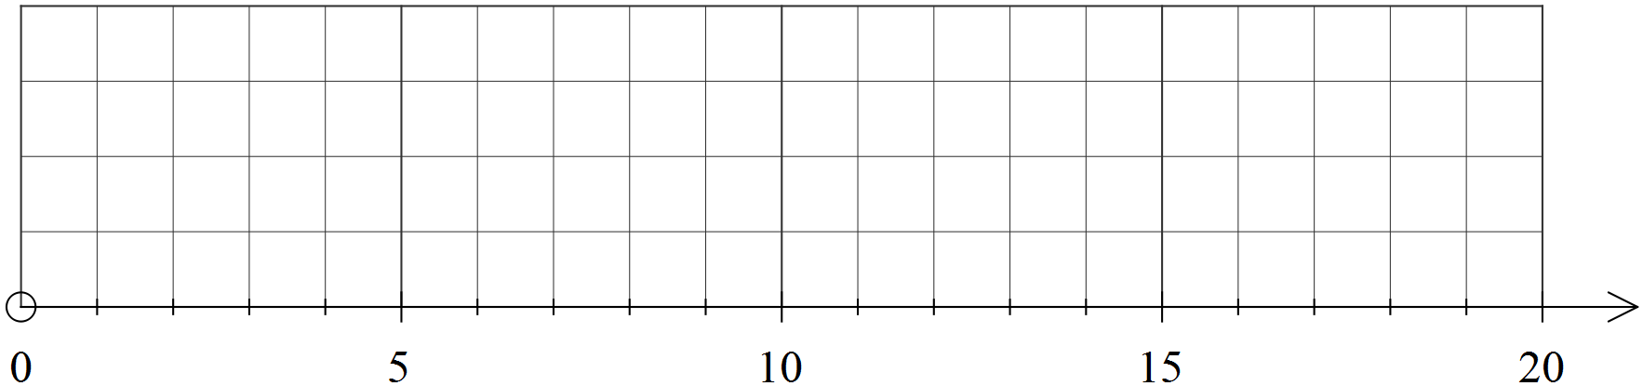

Question 5 (5 marks)
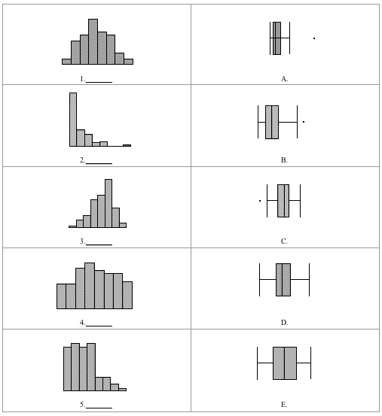
Consider all of the graphs (to the right) the histograms and the boxplots, to be on the same scale.

Match each histogram with its corresponding boxplot, by writing the letter of the box plot in the space provided.

Question 6
(1,1,2,2,2 – 8 Marks)
Two PE classes of students have their pulse rates (in beats per minute) measured. The results are shown in these box plots.
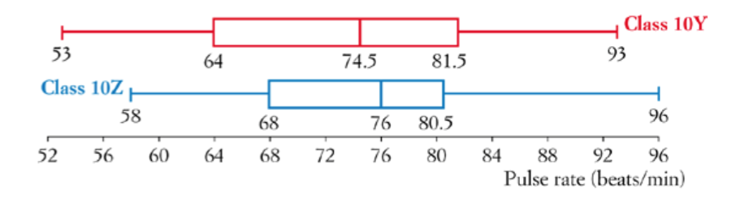
- What was the lowest pulse rate across both classes?

- Find the interquartile range for class 10Z.

- If there are 24 students in class 10Y, how many had a pulse rate between 74.5 and 81.5?

- Which class had the higher pulse rate on average? How does the box plot show this?

- Which class had more spread of pulse rates? How does the box plot show this?

Question 7 (5, 4,2 -8 Marks)
The data below gives the average monthly minimum daily temperatures of two Australian cities. The months are in order: January to December.

City X: 11.2, 11.8, 13.2, 9.3, 7.4, 5.8, 4.3, 5.9, 6.9, 19.8, 18.3, 12.4
City Y: 23.2, 22.6, 18.4, 14.5, 7.2, 4.1, 3, 6.9, 8.7, 13.1, 18.3, 22.4

(a) Find the five-number summary for each city.

(b) Draw a parallel box plot for the two cities.


(c) Write a couple of sentences comparing and contrasting the two cities.

~End of Test~

